Claeys Xavier  2 Place Puvis de Chavannes - 69006 Lyon  Mob: +33 (0)6.52.78.45.45  Mail: claeys.xavier@gmail.com  42 years - Married – 3 children | 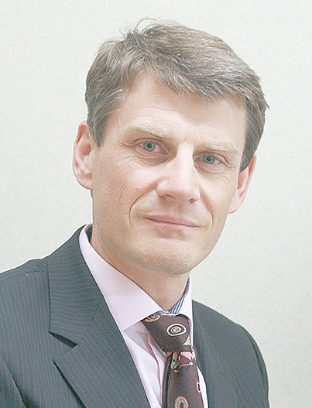
Doctor of Engineering
Grenoble Institute of Technology

Key Competencies
 |  | Project Management (>10M€)  Worldwide Team management (50p, 6 direct reports)  CMMI best practices  Languages :  French (native) - English (fluent) - German (beginner) |  | Technical :  Telematic & Embedded systems technologies  Safety and dependability (iso26262, iso13849)  Automatic control, numerical simulation, modeling and prototyping tools (Matlab, Labview, Dspace, C)  Electronics, Power Systems, Signal Processing.
Work experience
Global Senior Manager Engineering, software for tower – mobile and lattice crane products (6 direct reports, 50 Engineers)  The Manitowoc company | 
April 2014 – Today | France (Lyon area), USA (Pennsylvania, Wisconsin), Germany (Wilhelmshaven)
- Staff and manage a mixed matrix global engineering organization of crane technical experts and software Center Of Excellence (CoE).
- Global Leader for operation, standardization, innovation and collaboration with external research institutes, suppliers and low cost engineering center in Pune, India.
Results:
- Set up software team key deliverable and KPI. Measure capability to achieve expected functionalities with proper level of validation, quality respecting the planning.
- New project design review with complex content (safety functions, control systems, human machine interface, maintenance & telematic)
- Support launch of several very innovative new products, for example tower cranes MDT 219 or lattice crane MLC650 and more to come.
Electric and Electronic crane technologies innovation leader
The Manitowoc company
September 2011 – April 2014 | Lyon, France
- Implement advanced methodologies for the design and optimization of crane systems and new telematics services.
- Train Center Of Excellence (CoE) to system engineering and iterative project management techniques.
- Implement and assess new safety control standards to fulfill ISO 13849 regulation.
- Develop external partnership for innovation collaborative research.
- Conduct 2011-2012-2013-2014 French tax return programs for Manitowoc France (CIR).

Results:

Specify innovative crane driving controls or safety mechanism (2 patents, use of model based design), install new software validation tools and processes like «hardware in the Loop » (HIL) test bench. Collaborative research with Paris Mines School, ITWM Fraunhofer, CETIM, innovative startups, Pune offshore engineering design centers. Provide internal or external control engineering seminars. Conduct and release new software standard and processes.

Team leader, engine control safety and dependability (20 direct reports)  Renault DCMAP – Power Train Control and Tuning Division  2009-2011 | Paris, France | 
Management of a team of engineers and technicians in charge of power train functional safety: risks analysis, safety requirements identification and validation, safety plan writing (power train = engine or transmission control systems).
Results:
Safety and dependability validation process definition through the lead of transversal workshop within the complex organization, assignment and control of team individual objectives, change conduct through every day coaching, animation, and crew training. The first engine to experiment successfully this process was the last 1.6l dci Stop & Start Renault engine.
Project manager, diesel engine control systems
Renault DCMAP – Power Train Control and Tuning Division
2007-2008 | Paris, France
Responsible of the engine control system for several vehicles of Renault product line: technical choices, budget , planning, resources management, first rank suppliers follow up, project quality reporting.
Results:
Best in class 2.0l engine on Laguna 3, technical support to new Korean engine design office, conduct of an important cost reduction program on the 2.0l Trafic engine.
Research engineer, chassis - power train and ITS control systems
Renault DEA – Advanced Electronic Division
2002-2006 | Paris, France
Advanced control systems design.
Results:
40 patents, 3 Renault innovation awards (hybrid vehicle control architecture, anti-lock braking system for electrical vehicles, active steering).
Industrial research fellow, mechanical engineering  Berkeley University  2000-2001 | California – USA | 
Tire road slip estimation and modeling
Results:
Contribution to several conferences and journal papers, increase Renault’s international network with Universities or Research Institutes in the US (UC Berkeley, UC Davis, UCLA, Ford Research Lab).
PhD research fellow, autonomous vehicle control  Gipsa Laboratory (CNRS / INPG) - Renault Trucks  1997-2002 | Grenoble, France | 
Control design of autonomous vehicle system : lane keeping or autonomous trajectory following for heavy-duty vehicles
Results:
Platoon demo of heavy duty vehicles for Promote European community project.

 | Education
1997-2002: PhD – “Grenoble Institute of Technology”
Degree in control system technology from Grenoble Polytechnic Institute (INPG)
2002’ Grenoble city council award
1994-1997: Master of sciences – Télécom Physique Strasbourg
Master degree in electrical engineering from Strasbourg French engineering school
Master degree in Photonic and Vision systems (Graduation from ULP, Louis Pasteur University)
1991-1994: “Math’Sup, Math’Spé” – “Lycée Champollion” - Grenoble
Advanced mathematics and physics classes

